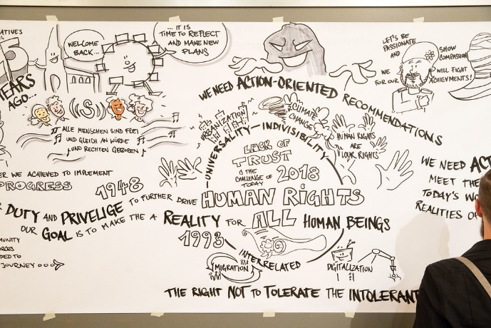
You are asked to write another blog entry for our project website.
Watch the following videos about modern day slavery and write this blog entry commenting on the following statement by Desmond Tutu, a South African civil rights activist (1931 – 2021):
"It means a great deal to those who are oppressed to know that they are not alone. Never let anyone tell you that what you are doing is insignificant."
(c) photonews.at/Anna Rauchenberger (https://www.flickr.com/photos/minoritenplatz8/28444210778)

(1) Modern day slavery:
https://www.youtube.com/watch?v=OqV4rh0xMRM
(2) Human trafficking
https://www.youtube.com/watch?v=g0xWMXaYdBk
(3) Congo: Cobalt Mines:
https://www.youtube.com/watch?v=JcJ8me22NVs ¹




(4) Bangladesh clothing factory:

https://www.youtube.com/watch?v=W1mvcFuiTts ¹


(5) Child labour India:
https://www.youtube.com/watch?v=zXg9y2tOJ74


(6) Child soldiers:
(7) Domestic Staff in Britain
https://www.youtube.com/watch?v=V1V6QGrOFvA

https://www.youtube.com/watch?v=bUeE12vXDs0 ¹


Original sources: (1) The Guardian: https://www.theguardian.com/global-development/video/2017/jul/31/why-are-millions-of-people-still-trapped-in-slavery-video); (3) SkyNews: https://news.sky.com/story/meet-dorsen-8-who-mines-cobalt-to-make-your-smartphone-work-10784120; (4) CBS News: https://www.cbsnews.com/news/cbs-news-goes-undercover-in-a-bangladesh-clothing-factory/ ; (6) TRT News: https://www.trtworld.com/video/rendezvous/the-harsh-reality-of-child-soldiers/5a96b1f0589d8247e2146e4b; (7) The Guardian: https://www.theguardian.com/global-development/video/2016/jan/11/i-was-just-a-slave-the-foreign-domestic-staff-living-a-life-of-five-star-serfdom-in-london-video Auf dieser Seite wird Software / werden Dienste / Videos vorgestellt, bei denen Daten auf externen Servern verarbeitet werden können. Die Nutzung ist für Sie freiwillig. Bei der Verwendung von Daten Dritter sind die rechtlichen Rahmenbedingungen zu beachten.

