
M5: AMERICAN OXYGEN © RIHANNA, 2015
https://www.youtube.com/watch?v=Ao8cGLIMtvg
- Getting started: Note down your associations with the title of the song.

- Listen to the song and have a look at the lyrics:

- Choose words that describe how the song makes you feel (and be prepared to explain why.)
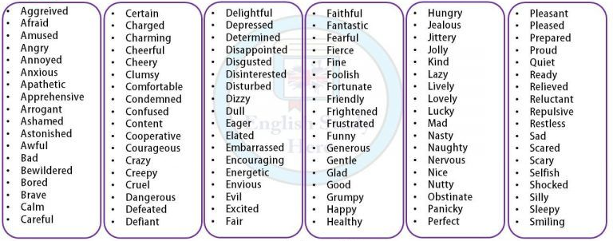
https://i.pinimg.com/originals/ce/bc/99/cebc99d2bdc5ff361c74cbd2da643f40.jpg (last accessed: March 19, 2023)

- Have a look at the text and try to summarize the main message of the song.

Breathe out, breathe in
American oxygen
Every breath I breathe²
Chasin' this American Dream
We sweat for a nickel and a dime³
Turn it into an empire
Breathe in, this feeling
American, American oxygen
American oxygen
Breathe in, this feeling
American, American Oxygen
Oh say can you see⁴, this is the American Dream
Young girl, hustlin'⁵
On the other side of the ocean
You can be anything at all
In America, America
I say, can't you see
Just close your eyes and breathe
Auf dieser Seite wird Software / werden Dienste / Videos vorgestellt, bei denen Daten auf externen Servern verarbeitet werden können. Die Nutzung ist für Sie freiwillig. Bei der Verwendung von Daten Dritter sind die rechtlichen Rahmenbedingungen zu beachten.
Breathe out, breathe in
American oxygen
Every breath I breathe
Chasin' this American Dream
We sweat for a nickel and a dime
Turn it into an empire
Breathe in, this feeling
American, American oxygen
American oxygen
Breathe in, this feeling
American, American Oxygen
American oxygen
Breathe in, this feeling
American, American Oxygen
Oh say can you see, this is the American Dream
Young boy, hustlin'
Tryna⁶ get the wheels in motion
But he can be anything at all
In America, America
I say, can't you see
Just close your eyes and breathe

(3) Now watch the video :

- Use a second color and mark the words in (2a) which you would choose now.
- Try to identify some of the scenes presented in the video and complete the mind map below.

USA

(4) Good angel or bad angel? Take your notes as a starting point and discuss this question.

oxygen = O₂(Sauerstoff); ² to breathe = atmen, breath = Atem; ³ nickel = 5 cents, dime = 10 cents ⁴ Oh say can you see” = first line of the US national anthem (Hymne) ⁵ to hustle: double meaning = to hurry / to be a prostitute ⁶ tryna = trying to .

